AN EFFICIENT APPROACH FOR SEGMENTATION AND CLASSIFICATION OF BRAIN TUMOR MRI IMAGES
¹Karthikeyan.R, ²Manivanan.M, ³Mukeshkumar.R, ⁴Dr.S.Kumarganesh
^{1to3}UG Scholar, ECE, Paavai Engineering College, Pachal, Namakkal
⁴Professor, ECE, Paavai Engineering College, Pachal, Namakkal
¹karthirama23@gmail.com, ³mukeshkumar71998@gmail.com,

Abstract—The identification, segmentation and detection of infecting area in brain tumor MR images are a tiresome and time consuming task. The diverse analysis structure of human body can be visualized by an image processing concepts. It is very complex to have idea about the irregular structures of human brain with simple imaging techniques. Magnetic resonance imaging technique distinguishes and clarifies the neural structural design of human brain. MRI technique contains many imaging modalities that scans and confine the internal structure of human brain. In this study, we have intense on noise removal technique, withdrawal of gray-level co-occurrence matrix (GLCM) features, DWT-based brain tumor region mounting segmentation to decrease the complexity and develop the performance. This was followed by morphological filtering which removes the noise that can be twisted after segmentation. The probabilistic neural network classifier was used to instruct and check the performance accuracy in the detection of tumor position in brain MRI images. The experimental results achieved nearly 100% accuracy in identifying ordinary and unusual tissues from brain MR images representing the effectiveness of the proposed technique.
Keywords— Image segmentation, MRI, DWT, Morphology, GLCM, PNN
- INTRODUCTION
In image processing, images transmit the information where input image is processed to get output also an image. In today’s humanity the images used are in digital format. In modern times, the introduction of information technology and e-healthcare system in medical field helps clinical experts to offer better health care for patients. This study reveals the problem segmentation of unusual and usual tissues from MR images using gray-level co-occurrence matrix (GLCM) quality extraction and probabilistic neural network (PNN) classifier. The brain tumor is an irregular growth of abandoned cancerous tissues in the brain. A brain tumor can be gentle and cruel. The gentle tumor has uniformity structures and contains non-active cancer cells. The cruel tumor has non-uniformity structures and contains active cancer cells that stretch all over parts. According to world health organization, the grading system scales are used from grade I to grade IV. These grades classify gentle and cruel tumor types. The grade I and II are low-level grade tumors while grade III and IV are high-level grade tumors. Brain tumor can affect those at any age. The force on every person may not be same. Due to such a difficult structure of human brain, a analysis of tumor area in brain is challenging task. The cruel-type grade III and IV of tumor is fast growing. It affects the healthy brain cells and may extend to other parts of the brain or spinal cord and is more destructive and may remain unprocessed. So detection of such brain tumor location, identification and classification in previous stage is a serious issue in medical science. By enhancing the new imaging techniques, it helps the doctors to examine and track the incident and growth of tumor-affected regions at different stages so that they can offer suitable diagnosis with these images scanning. The key issue was detection of brain tumor in very premature stages so that proper treatment can be adopted. Based on this information, the most appropriate

therapy, radiation, surgery or chemotherapy can be determined. As a result, it is obvious that the chances of survival of a tumor-infected patient can be improved significantly if the tumor is detected perfectly in its premature stage. The segmentation was employed to determine the precious tumor part using imaging modalities. Segmentation is process of isolating the image to its essential parts sharing identical properties such as color, texture, contrast and boundaries.

- PROPOSED METHODOLOGY

This describes the equipment, the cause from which the brain image data composed and the algorithms for brain MRI segmentation and quality extraction. The methodology proposed includes application on brain MRI images of 256 X 256, 512 X 512 pixel size on dataset. It is transformed into gray scale for further improvement. The following discussion deals with performance of algorithm.

Input Image

Pre-processing stage
(Noise Removal)

Feature extraction using DWT

Feature extraction using GLCM

Image Segmentation

- PREPROCESSING
The preprocessing stage improves the pattern of the brain tumor MR images and makes these images suitable for future processing by clinical experts or imaging modalities. It also helps in recovering parameters of MR images. The parameters includes enhancement in signal-to-noise ratio, improvement in visual appearance of MR images, the removal of immaterial noise and surroundings of undesired parts, smoothing regions of inner part, maintaining related edges.

Segmentation
The segmentation is a process where the image is partitioned into dissimilar regions. Let an total region of image be represented by S. Segmentation process can be viewed as division of S into p sub regions like S1, S2, S3, …Sp. Certain conditions has to fulfilled such as the segmentation must be integral; that is each and every pixel should be inside the region, every points in the regions should be attached in some sense, regions should be disjoint, etc.Describe abbreviations and acronyms the initial time they are used in the content, even after they have been defined in the abstract. Abbreviations such as IEEE, SI, MKS, CGS, sc, dc, and rms do not have to be distinct. Do not use abbreviations in the title or heads if not they are unavoidable.

Region growing
Region growing is combination of pixels or sub regions into larger regions based on definite criteria. The main aim was to select a ‘seed’ points and connect each of these seed to those neighbouring pixels having the same properties to grow region. A place of seeds was taken as input inside the image and marked the objects to be segmented. The region grows iteratively by estimating all unallocated neighbouring pixels of the section. The comparison was the measure of distinction between pixel’s intensity value and the region’s mean d. The pixel with the smallest distinction measured this way was allocated to the individual region. This was sustained until all pixels were allocated to a region. Seeded region growing requires seeds as extra input. The results depend on the collection of seeds. The quantity was based on mean value of the pixel intensity. The image gets segmented; this image was used to recognize the desired tumor region.

- MORPHOLOGICAL OPERATION

Morphology deals with study of shapes and boundary area removal from brain tumor images. Morphological operation is rearranging the command of pixel values. It operates on structuring element and input images. Structuring elements are attributes that probes a type of interest. The basic operations used here are dilation and corrosion. Dilation operation adds the pixels to boundary region, while corrosion removes the pixels from the boundary region of the substance. These operations were passed out based on the structuring elements. Dilation chooses maximum value by comparing all pixel values in neighbourhood of input image described by structuring element, whereas corrosion chooses the smallest value by comparing all the pixel values in the neighbourhood of the input image.

- FEATURE EXTRACTION

Feature extraction is method of extracting quantitative information from an image such as color features, texture, shape and contrast. Here, we have used discrete wavelet transform (DWT) for extracting wavelet coefficients and gray-level co-occurrence matrix (GLCM) for numerical feature extraction.

- Feature extraction using DWT

The wavelet was used to analyze different frequencies of an image using dissimilar scales. Here, we are using discrete wavelet transform (DWT) which is dominant tool for feature extraction. It was used to remove coefficient of wavelets from brain MR images. The wavelet localizes frequency in sequence of signal function which was essential for classification. 2D discrete wavelet transform was useful that resulted in four sub bands LL (low–low), HL(high–low),LH(low– high), HH(high–high) with the two-level wavelet breakdown of Region of Interest (ROI). The 2D level breakdown of an image displays an estimate with detailed three images that represents low and high-level frequency inside in an image, respectively. The wavelets approximations at first and second level are represented by LL1, LL2, correspondingly; these characterize the low-frequency part of the images. The high-frequency part of the images are represented by LH1, HL1, HH1, LH2, HL2 and HH2 which gives the particulars of horizontal, vertical and transverse directions at first and second level, respectively. We have used low-level image, where LL1 represents the estimate of original image and is further decayed to second-level approximation and details of image. The process was constant until we obtained the required level of resolution. By using 2D discrete wavelet transform, the images were decayed into spatial frequency mechanism were extracted from LL sub bands and since HL sub bands have higher performance when compared to LL, we have used equally LL and HL for better analysis which describes image text features. The different frequency mechanism and each module were studied with resolution matched to its scale and expressed as:

DWT p(s) = {di.j =∑p(s)h*i(s-2ij) (1)
di.j =∑p(s)g* i(s-2ij)

The coefficients di.j refers to the component feature in signal p(s) equivalent to the wavelet function, whereas bi,j refer to the approximated mechanism in the signal. The functions h(s) and g(s) in the equation represent high-pass and low-pass filters coefficients, correspondingly, while parameters i and j refer to wavelet scale and translation N factors.

- Feature extraction using GLCM

Texture analysis differentiates regular and irregular tissues simply for human visual perception and machine learning. It also provides deviation between cruel and regular tissues, which may not be visible to human eye. It improve the precision by choosing effective quantitative features for early analysis. In the initial step, the first-order statistical textural analysis-features in sequence from the histogram of image intensities was extracted and frequencies of gray level at a random image positions were calculated. It does not consider connection or co-occurrences, among pixels. In the second step, the second-order textural analysis-features were extracted based on possibility of gray levels at random distances and over full image orientations. The statistical features were extracted using gray-level co-occurrence matrix (GLCM), also identified gray-level spatial dependence matrix (GLSDM). GLCM was introduced by Haralick. It is an approach that describes the spatial relation among pixels of various gray-level values. Gray-level co occurrence matrix (GLCM) is 2D histogram in which (p,q)th elements is the occurrence of event p occurs with q. It is a function of space S = 1, angle (at 0 (horizontal), 45(with the positive diagonal), 90(vertical) and 135 (negative diagonal) and gray scales p and q, and calculates how frequently a pixel with intensity p, occurs in relation with another pixel q at a definite space S and orientation. In this method, gray-level co-occurrence matrix was initiated and the textural features such as contrast, correlation, energy, homogeneity, entropy and variance were obtained from LL and HL sub bands of first four levels of wavelet corrosion . The textural features extracted are scheduled below:

Contrast (CONT): Measurement of pixel intensities and its neighbours beyond image and given by the equation:

m-1 n-1
CONT=∑ ∑ (x-y) ^2f(x,y) (2)
x=0 y=0

Energy (ENG): Energy defines the quantitative amount of tedious pixel pairs. It is the capacity of attraction in an image, given by equation:

ENG=√ i-1 j-1
∑ ∑ f^2(p,q) (3)
p=0 q=0

Correlation (COR): The measurement of spatial features dependencies among the pixels.

i-1 j-1
∑ ∑ (p,q)f(p,q) -MpMq
p=0 q=0
COR = ----------------------------------- (4)
σpσq

Homogeneity (HOM ): Measurement of limited consistency
in an image. It is also known as opposite difference moment
and contains a single or more variety of values to differentiate
between textured and non-textured.

i-1 j-1 1
HOM= ∑ ∑ -----------------f (p,q) (5)
p=0 q=0 1+ (p-q)^2

Entropy (ENT): It calculates the selected intervention of the textural image. It is given as:

i-1 j-1
ENT= − ∑ ∑ f(p,q) log2f(p,q) (6)
p=0 q=0

After the textural features extraction, the subsequent features estimation parameter are also necessary to be obtained for better analysis on brain MR images.

Peak signal-to-noise ratio (PSNR): It is a measure used to estimate the attribute features of reconstructed image from processed image. It is given as:

2^m−1
PSNR=20 log10 ------------- (7)
MSE
Lower the rate of mean square error and higher rate of peak signal-to-noise ratio specify better signal-to-noise ratio.

Mean Square Error (MSE): Measure of reliability of signal or image. It was used to evaluate two images by giving quantitative or comparison scores.
1
MSE= ------------∑ ∑(f(i,j) – f^R(i,j))^2 (8)
P X Q

These extracted statistical features were feed into probabilistic neural network (PNN) classifier as an effort for guidance and testing the performance of classifier in the arrangement of brain tumor images into regular and irregular.

4. SUPPORT VECTOR MACHINE (SVM)

Support Vector Machine (SVM) introduced by Cortes is generally used for classification purpose. SVMs are efficient learning approaches for training classifiers based on several functions like polynomial functions, radial basis functions, neural networks etc. It is considered as a supervised learning approach that produces input-output mapping functions from a labeled training dataset. SVM has significant learning ability and hence is broadly applied in pattern recognition. Support vector machines are supervised learning models with associated learning algorithms that analyze data and recognize patterns, used for classification. The basic SVM takes a set of input data and for each given input, predicts which of two classes forms

RESULT AND DISCUSSION

In this explore, we have used two datasets, one was trained dataset and the other was test dataset. These datasets were built by qualified radiologists; this includes sample images of five patients with all modalities. The data were composed from digital imaging and interactions in medicine dataset. We have measured 650 composed samples from the 25 images of DICOM dataset, of which 18 are infected tumor brain tissues and others normal for the analysis. Form the review, the directional features extracted from LL and HL sub bands wavelet transform gives the complete information of different directions with more efficient with characterization changes in biological tissues. The MR images were decayed into five different levels from which the complete coefficients from LL and HL sub bands were selected. These sub bands were obtained from wavelet decayed; the numerical textural features such as energy, correlation, entropy, and homogeneity were extracted using gray-level co-occurrence matrix (GLCM). The textural features obtained from different levels of wavelet decay were taken into reflection and were used as input from training and testing the presentation of PNN classifier. The image 1 to image 10 shows diverse levels of sub bands up to 5th level of wavelet decay. These extracted features were used as input vectors for training and testing the presentation of PNN classifier. Tables 1 and 2 show the numerical textural features such as correlation, contrast, energy, homogeneity and entropy obtained from gray-level co-occurrences matrix formed from diverse levels of LL and HL sub bands of all five levels of trained and tested images (Figs. 1 and 2).

Table 1: The numerical features obtained from gray-level co occurrence matrix (GLCM) of LL and HL sub bands of trained images

Images CON COR ENE HOM ENT

Image 1 0.0116 0.0710 0.975 0.900 0.337
Image 2 0.0112 0.0206 0.977 0.903 0.332
Image 3 0.0036 0.0381 0.992 0.965 0.339
Image 4 0.0139 0.0067 0.973 0.927 0.395
Image 5 0.0168 0.0259 0.966 0.901 0.337
Image 6 0.0054 0.0027 0.989 0.766 0.272
Image 7 0.0138 0.0069 0.972 0.678 0.275
Image 8 0.0047 0.0288 0.990 0.467 0.337
Image 9 0.0162 0.0081 0.967 0.732 0.272
Image 10 0.0125 0.0477 0.974 0.683 0.337

Table 2: The numerical features obtained from gray-level co occurrence matrix (GLCM) of LL and HL sub bands of tested images

Images CON COR ENE HOM ENT

Image 1 0.0098 0.0510 0.856 0.930 0.228
Image 2 0.0073 0.0198 0.899 0.870 0.389
Image 3 0.0110 0.0295 0.954 0.910 0.321
Image 4 0.0095 0.0054 0.774 0.882 0.350
Image 5 0.0120 0.0243 0.832 0.891 0.302
Image 6 0.0043 0.0034 0.820 0.745 0.253
Image 7 0.0100 0.0056 0.854 0.798 0.265
Image 8 0.0030 0.0266 0.860 0.950 0.330
Image 9 0.0130 0.0071 0.789 0.947 0.232
Image 10 0.0108 0.0450 0.893 0.864 0.330

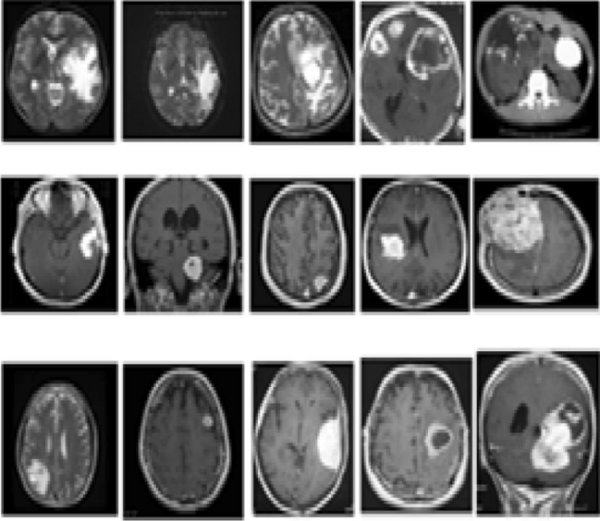

Fig. 2: Brain tumor image dataset

The performance investigation of segmented images with the calculation of area is tabulated in Table 3. A lesser value of MSE and a upper value of PSNR indicate better signal-to-noise ratio in the extracted image. From the observation, the contrast of trained MR images obtained was found to be extra when compared to tested MR images, whereas the homogeneity of trained MR images was found to be fewer when compared to tested MR images. Similarly, the entropy and energy are found extra in trained MR images when compared to tested MR images. With this proposed methodology and with the help of numerical textural features (contrast, correlation, energy, homogeneity and entropy) procured from LL and HL sub bands classified the brain tumor images into regular and irregular. The differences in numerical textural feature values of trained and tested brain tumors were found to be very useful in manipulating the presentation of the PNN classifier in training and testing.

Table 3: The presentation evaluation and area calculation of tumor extracted region of trained images

Images PSNR MSE Area of image Area of tumor
in pixel region

Image 1 14.011 6.121 39,240 7698
Image 2 13.82 3.116 67,824 9874
Image 3 14.12 8.068 50,508 7423
Image 4 13.86 4.77 50,388 9056
Image 5 13.79 5.84 24,964 4564
Image 6 13.82 7.79 50,429 3698
Image 7 13.99 6.92 50,298 5879
Image 8 14.004 7.35 35,040 13,923
Image 9 14.066 6.215 50,544 6534
Image 10 14.03 6.172 16,384 4497

- PERFORMANCE ANALYSIS

The trained dataset images for which the features extracted were trained using probabilistic neural network (PNN) classifier for the arrangement purpose, whereas the test dataset was not trained using PNN classifier, only the numerical and textural features were extracted. The exactness of trained and tested image was compared based on the classification of regular and irregular tumor tissues. Exactness or correct rate of arrangement is the efficiency of suitable arrangement to the total number of arrangement tests. This process of brain tumor arrangement has been performed on various regular and irregular MR images, and the exactness of the PNN classifier is manipulated, using the equation given below:

Correct cases
Accuracy (%) = ------------------ x 100 (9)
Total number

- CONCLUSION AND FUTURE SCOPE

In this explore, we have used brain MR images, segmented into typical brain tissue (unchanged) and irregular tumor tissue (infected). To eliminate a noise and smoothen the image, preprocessing is used which also results in the enhancement of signal-to-noise ratio. Next, we have used discrete wavelet transform that decomposes the images and textural features were extracted from gray-level co-occurrence matrix (GLCM) followed by morphological operation. Probabilistic neural network (PNN) classifier is used for the arrangement of tumors from brain MRI images. From the observation results, it can be obviously expressed that the recognition of brain tumor is quick and perfect when compared to the physical detection passed out by clinical experts. The performance factors evaluated also shows that it gives recovered outcome by improving PSNR and MSE parameters. The proposed methodology results in perfect and quick detection of tumor in brain along with arrangement of exact location of the tumor. In identification and arrangement into regular and irregular tumors from brain MR images, accuracy of nearly 100% was achieved for trained dataset because the numerical textural features were extracted from LL and HL sub bands wavelet decay and 95% was achieved for tested dataset.

The observation results are shown in Fig. 3 representing Input image with salt and pepper noise, Noise removed and Feature extraction based on DWT.

(a)
Input image with salt Noise removed Feature extraction
and pepper noise based on DWT

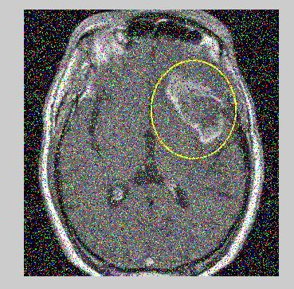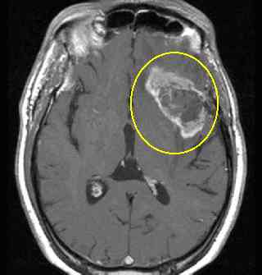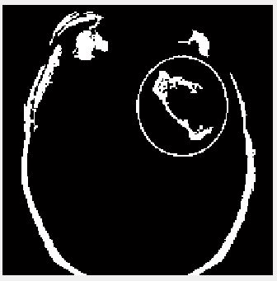

(b)
Input image with salt Noise removed Feature extraction
and pepper noise based on DWT

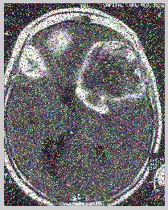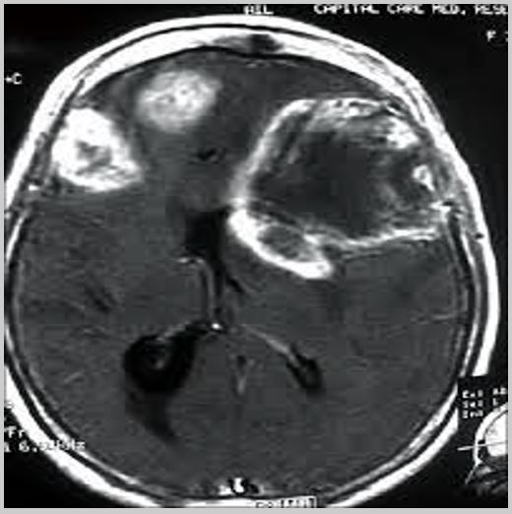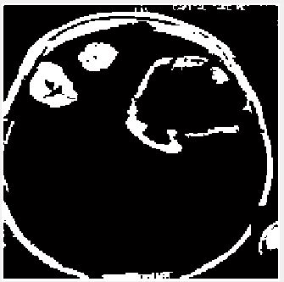

(c)
Input image with salt Noise removed Feature extraction
and pepper noise based on DWT

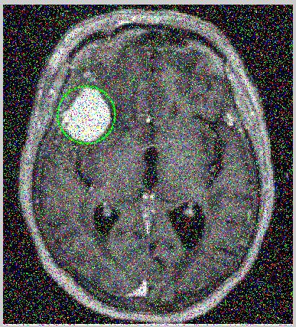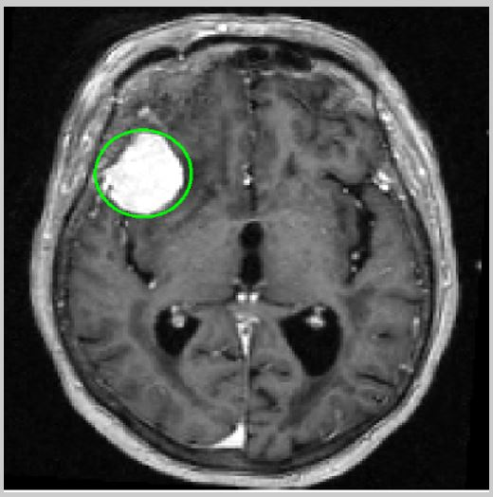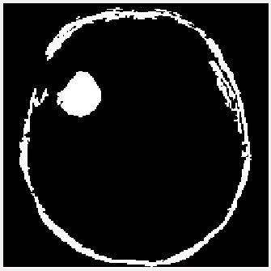

(d)
Input image with salt Noise removed Feature extraction
and pepper noise based on DWT

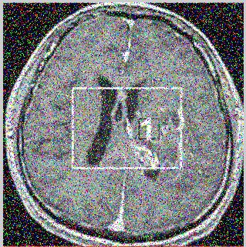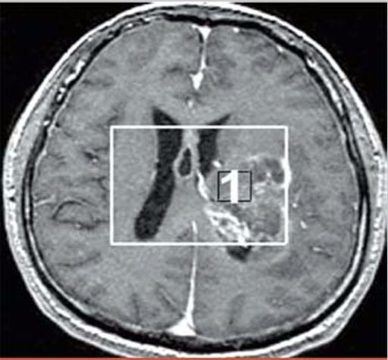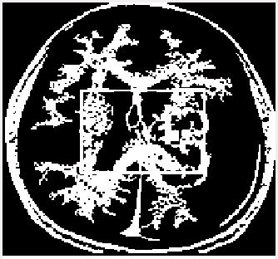

(e)
Input image with salt Noise removed Feature extraction
and pepper noise based on DWT

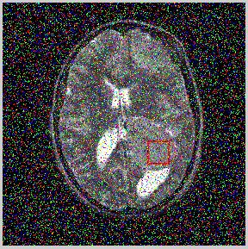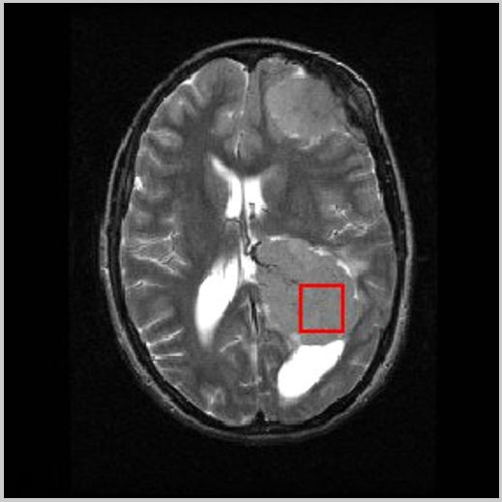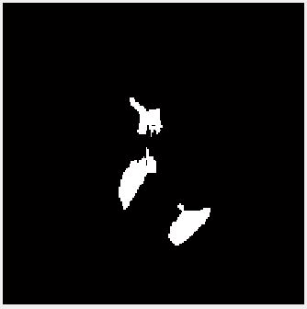

Fig 3: Feature extraction based on DWT

With the above results, we conclude that our proposed method clearly distinguishes the tumor into regular and irregular which helps in pleasing clear diagnosis decisions by medical experts. In the future work, different classifiers can be used to amplify the exactness combining more competent segmentation and feature extraction techniques with real- and medical-based cases by using large dataset covering dissimilar scenarios.

REFERENCES

- Yan Na , Li Zhao , Yingxue Yang, Mengqiao Ren, 2018 “Guided filter-based images fusion algorithm for CT and MRI medical images”, Vol. 12 Iss. 1, pp. 138-148.
- Zhao, Y., Zhao, Q., Hao, A.: ‘Multimodal medical image fusion using improved multi-channel PCNN’, Biomed. Mater. Eng., 2014, 24, pp. 221–228
- Chen, L., Pan, J., Chen, C.: ‘Clinical research of target contour in NPC IMRT using CT/MRI fusion technique’, Int. Med. Health Guid. News, 2008, 14, (1), pp. 4–7
- Wang, L., Tao, L., Wang, H.: ‘The research on evaluate measure of CT and MRI image fusion’, J. Biomed. Eng. Res., 2006, 25, (4), pp. 247–250
- Lizhen, C.A.O., Li, K., Zhao, X.: ‘The diagnostic application of registration of CT and MR images in craniocerebral tumour’, J. Clin. Radiol., 2004, 23, (12), pp. 1023–1026
- Xing, Z., Lin, Z.: ‘Fusion of PET images with CT and MR images in diagnosing tumours’, Chin. J. CT MRI, 2005, 25, (5), p. 290
- Rong, H., Hui, W., Xiaoxu, L.: ‘Observation of CT-MRI image fusion in postoperativeprecise radiotherapy for gliomas’, Chin. J. Radiat. Oncol. Biol., 2017, 26, (2), pp. 192–196
- Gan, X., Xu, Z., Liao, F.: ‘Application value of CT/MRI image fusion technique in the delineating of target area for radiotherapy of nasal pharyngeal cancer’, China Med. Dev., 2014, 29, (11), pp. 163–165
- Xu, Q., Zhou, Y., Wang, W., et al.: ‘An algorithm of remote sensing image fusion based on nonsubsampled contourlet transform’. 2012 5th Int. Congress on Image and Signal Processing, Chongqing, China, 2012, pp. 1005–1009
- Zhu, J., Che, J., Guo, Z.: ‘Curvelet algorithm of the remote sensing image fusion based on the local mean and standard deviation’, J. Ningxia Univ. (Nat. Sci. Ed.), 2014, 35, (1), pp. 24–27.
- Haralick RM, Shanmugam K, Dinstein I (1973) Textural features for image classification. IEEE Trans Syst Man Cyber 3(6):610–621

- Madhikar GV, Lokhande SS (2014) Detection and classification of brain tumour using modified region growing and neural network in MRI images. Int J Sci Res (IJSR) 3(12):5

- Vaishali et al. (2015) Wavelet based feature extraction for brain tumor diagnosis—a survey. Int J Res Appl Sci Eng Technol (IJRASET) 3(V), ISSN: 2321-9653

- Jadhav C et al (2014) Study of different brain tumor MRI image segmentation techniques. Int J Comput Sci Eng Technol (IJCSET) 4(4):133–136

